**Lab 9B**

**Lab 9b - Code**

**IC_student.py**

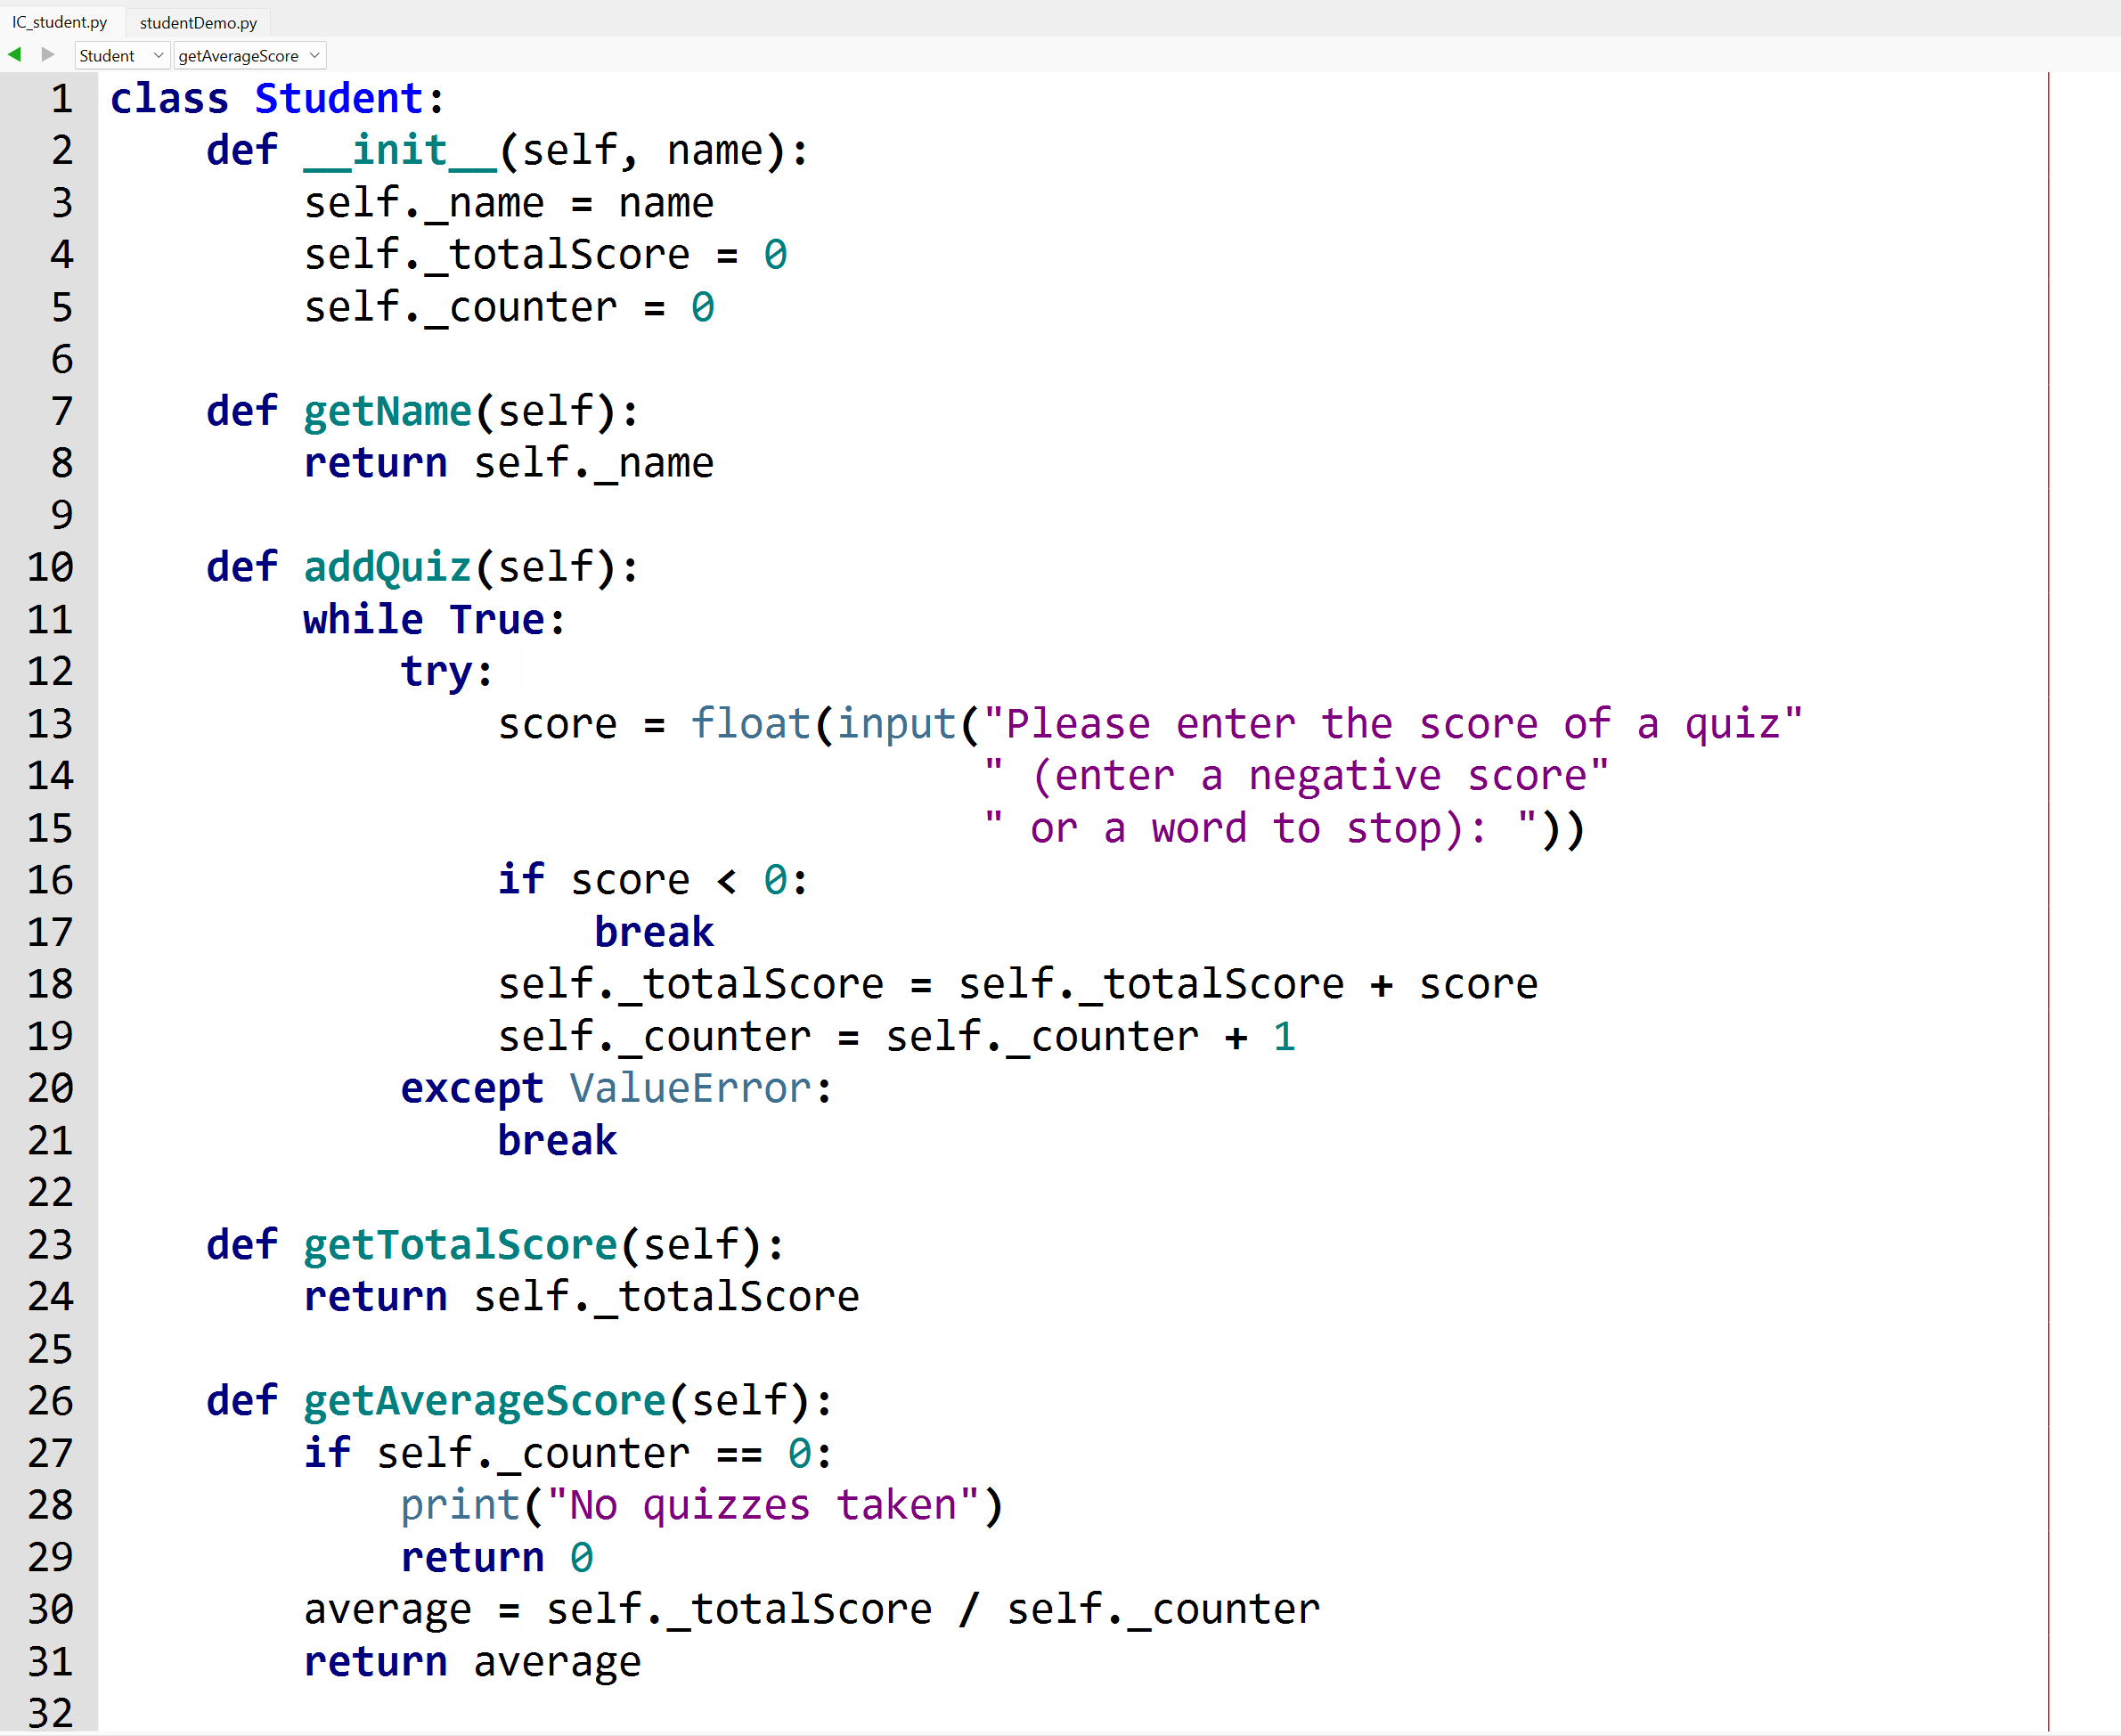

**studentDemo.py**

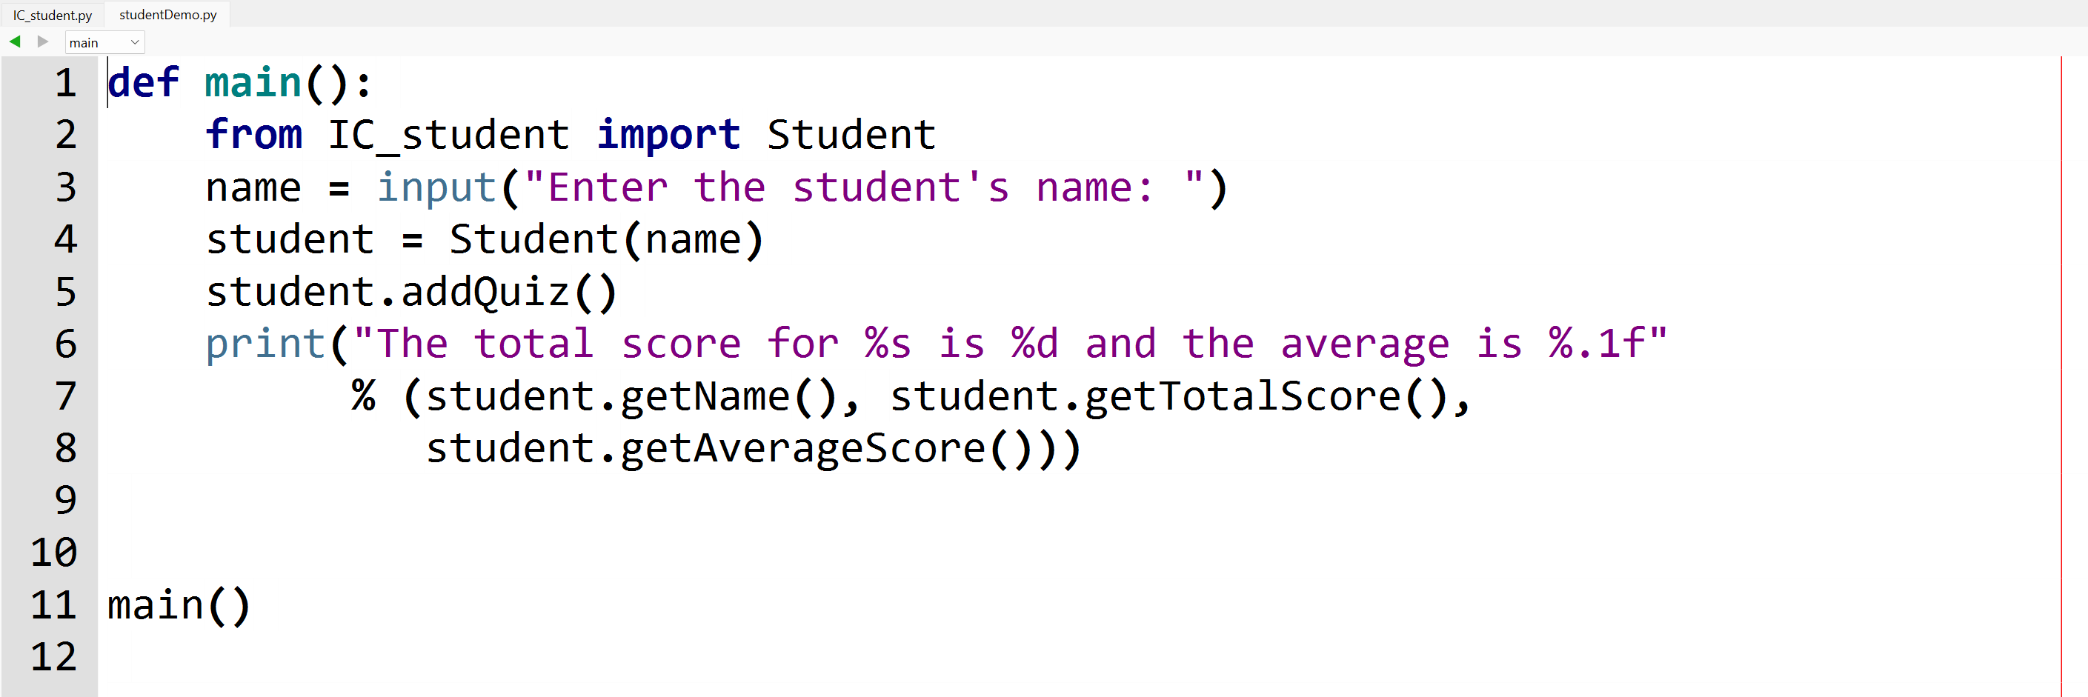

**Lab 9b - Output**

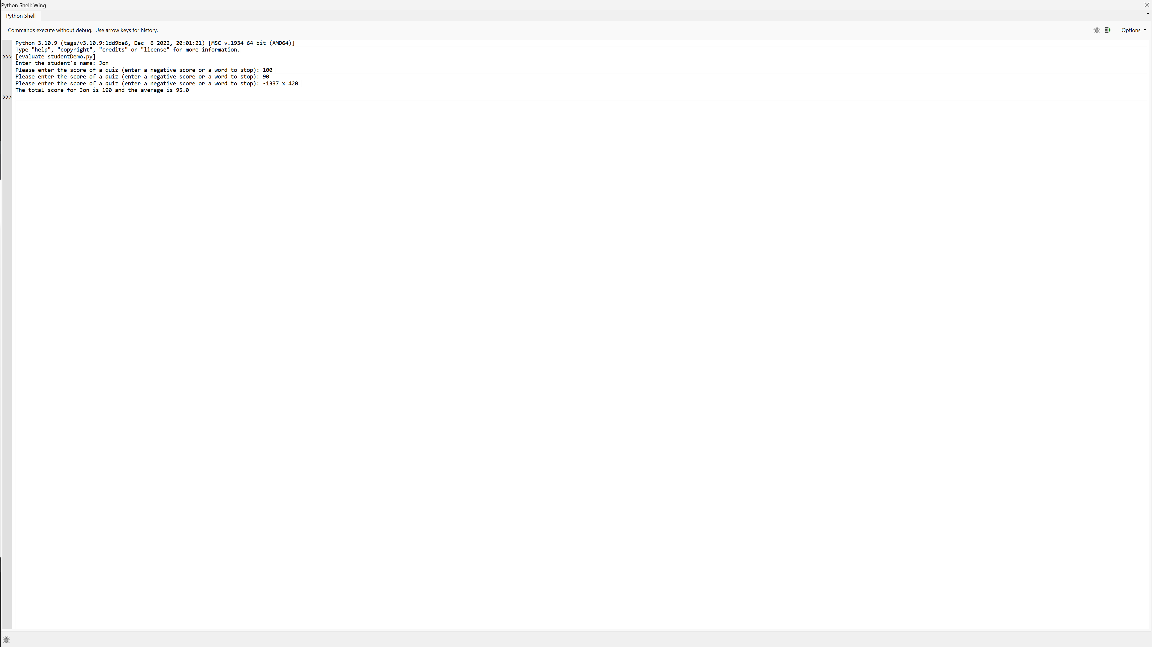

**Lab 9b – Written Code**

**IC_student.py**

class Student:  
 def __init__(*self*, name):  
 *self*._name = name  
 *self*._totalScore = 0  
 *self*._counter = 0  
  
 def getName(*self*):  
 return *self*._name  
  
 def addQuiz(*self*):  
 while True:  
 try:  
 score = float(input("Please enter the score of a quiz"  
 " (enter a negative score"  
 " or a word to stop): "))  
 if score < 0:  
 break  
 *self*._totalScore = *self*._totalScore + score  
 *self*._counter = *self*._counter + 1  
 except ValueError:  
 break  
  
 def getTotalScore(*self*):  
 return *self*._totalScore  
  
 def getAverageScore(*self*):  
 if *self*._counter == 0:  
 print("No quizzes taken")  
 return 0  
 average = *self*._totalScore / *self*._counter  
 return average

**studentDemo.py**

def main():  
 from IC_student import Student  
 name = input("Enter the student's name: ")  
 student = Student(name)  
 student.addQuiz()  
 print("The total score for %s is %d and the average is %.1f"  
 % (student.getName(), student.getTotalScore(),  
 student.getAverageScore()))  
  
  
main()